Clinical Knowledge Graph - Coditas

Network Database
A Network Database is a type of database that organizes data using a graph-like structure of records connected by links (pointers), allowing many-to-many relationships between entities. Unlike a hierarchical database (which has a tree structure), the network model lets records have multiple parent and child records, making data retrieval faster and more flexible for complex relationships.

Knowledge Graph
A Knowledge Graph is a structured representation of real-world entities such as people, places, events, and concepts and the relationships between them, organized as nodes (entities) and edges (connections). Unlike traditional databases that store data in isolated tables, a knowledge graph connects information in a network-like structure, enabling machines to understand context, infer new insights, and perform semantic searches. It combines data from multiple sources, enriches it with meaning using ontologies or schemas, and allows querying not just for data but for relationships and patterns. This makes knowledge graphs especially useful in domains like healthcare, finance, and recommendation systems, where understanding how data points relate is as important as the data itself.

Knowledge Graph / Graph-Database Platforms
- Neo4j
- Amazon Neptune
- Stardog
- GraphDB
- Apache Jena
Knowledge Graph VS Network Database
A Knowledge Graph is a type of graph database that not only stores data as nodes and relationships but also adds meaning and context using semantics, ontologies, and real-world relationships. In short, while a Graph Database focuses on how data is connected, a Knowledge Graph focuses on what those connections mean, making the data machine-understandable and useful for reasoning and AI applications.

Knowledge Graph VS ER-based RDBMS
A Knowledge Graph and an ER-based RDBMS model both represent entities and relationships, but in different ways. An ER (Entity-Relationship) model in a relational database stores data in tables with predefined schemas and foreign keys to link entities, making it rigid but structured. In contrast, a Knowledge Graph stores entities as nodes and relationships as edges, allowing flexible, semantic connections and easy linking of new data without altering the schema. This makes knowledge graphs better for representing complex, evolving real-world relationships.
Need of Knowledge Graph in Medicine and Clinical EHR data
Knowledge Graphs are very useful in medicine and clinical EHR data because they can connect diverse medical information
- Patients
- Hospital Admissions
- Unit Admissions
- ICU stays
- Diagnoses
- Lab Events
- Prescriptions
- Procedures
- Clinical Notes
into a single interconnected network instead of keeping it in isolated tables.
This helps doctors and researchers easily see relationships between diseases, symptoms, and treatments. They enable patient journey tracking, clinical decision support, drug–disease interaction detection, and predictive analytics. By integrating structured and unstructured data, knowledge graphs turn scattered medical records into an interconnected network of insights for better diagnosis and personalized care.
Example:
If a patient is diagnosed with diabetes, the graph connects the diagnosis to medications like Metformin and Insulin, along with their start and end dates, dosage, and follow-up lab results such as HbA1c levels. By querying the graph, clinicians can easily see which drugs were given, for how long, and when the patient’s condition improved, helping them understand the effectiveness and timeline of the treatment.
In short,
It helps in efficient storage of knowledge and making better decisions.
MIMIC-IV Database
MIMIC-IV (Medical Information Mart for Intensive Care IV) is a large, publicly available database developed by the MIT Laboratory for Computational Physiology. It contains detailed, de-identified electronic health records (EHR) of over 380,000 patients admitted to critical care units at the Beth Israel Deaconess Medical Center from 2008 to 2019. The database includes information on patient demographics, diagnoses, procedures, medications, lab results, vital signs, ICU stays, and clinical notes. MIMIC-IV is widely used in medical research, especially for studying critical care outcomes, developing predictive models, and advancing clinical decision support using AI and machine learning.
Steps to access MIMIC-IV data on PhysioNet:
- Create an account: Sign up on PhysioNet and verify your email.
- Complete CITI training: Take the “Data or Specimens Only Research” course and download the completion report.
- Apply for access: Go to the MIMIC-IV project page, request access, and upload your CITI report.
- Accept the Data Use Agreement: Review and sign the credentialed data license.
- Get approval and download: After approval, you can download MIMIC-IV or use available cloud-hosted versions.
MIMIC-IV Datasets (4 Modules):
- Hospital-Level Data (HOSP): Contains patient demographics, admissions, diagnoses, procedures, medications, and lab results from the hospital stay.
- ICU-Level Data (ICU): Includes detailed, time-stamped vital signs, interventions, and monitoring data from critical care units.
- Emergency Department Data (ED): Captures information from emergency visits such as triage details, vitals, labs, and discharge outcomes.
- Clinical Notes Data: Comprises unstructured text notes like discharge summaries, progress notes, and radiology reports written by clinicians.
Important Links
- https://physionet.org/content/mimiciv/3.1/
- https://physionet.org/content/mimic-iv-ed/2.2/
- https://physionet.org/content/mimic-iv-note/2.2/

Approximate Records within MIMIC-IV
- Patients : 364627
- Total Hospital admissions : 546028
- ICU stays : 94458
- Diagnosis : 112107
- Procedures : 86423
- Microbiology : 3988224
- Prescriptions : 20292611
- Input/output events : 10953713 + 5359395
How the Clinical Knowledge Graph System Works

Phase 1: Setting Up Patient Records and Hospital Visits
Step 1: Registering Patients
- Reads patient information (demographics, age, gender, etc.)
- Creates a node for each patient
Step 2: Tracking Patient Journey Through the Hospital
- Reads admission, transfer, and emergency department records
- Builds a timeline of events:
  - Emergency department visits
  - Hospital admissions
  - Transfers between units
  - Discharges
- Links events in chronological order
- Connects patients to their emergency visits
- Links emergency visits to hospital admissions when applicable
- Tracks how many times each patient was admitted
Step 3: Identifying Intensive Care Stays
- Identifies which stays were in the ICU
- Marks these stays and records ICU-specific details (units, length of stay)

Phase 2: Adding Medical Information
Step 1: Recording Medications
- Captures medications from different sources:
  - Medications the patient was taking before arrival (from emergency department records)
  - Medications given in the emergency department
  - Prescriptions ordered during the hospital stay
- Organizes medications by when and where they were recorded
Step 2: Recording Medical Procedures
- Captures procedures performed:
  - Procedures coded in hospital records
  - Procedures performed in the ICU
- Links procedures to the relevant hospital visit or stay
Step 3: Recording Diagnoses
- Captures diagnoses from:
  - Emergency department visits
  - Discharge summaries (primary and secondary diagnoses)
- Links diagnoses to the relevant visits
Step 4: Recording Laboratory Tests
- Captures lab results from throughout the hospital stay
- Organizes results by when and where they were performed
Step 5: Recording Diagnosis Groups
- Adds diagnosis-related group (DRG) codes assigned to hospital admissions
- Links these codes to the relevant admissions
Step 6: Recording Microbiology Tests
- Captures microbiology test results (cultures, sensitivities, etc.)
- Links them to the relevant lab records

Phase 3: Adding Provider and Assessment Information
Step 1: Recording Healthcare Providers
- Records which providers managed each hospital admission
- Links providers to the admissions they managed
Step 2: Recording Initial Assessments
- Captures triage assessments from emergency department visits
- Links assessments to the relevant emergency visits

Phase 4: Adding Patient History and Clinical Documentation
Step 1: Recording Past Medical History
- Captures the patient's past medical history
- Links it to the relevant hospital admission
Step 2: Updating Chief Complaints
- Standardizes and updates chief complaints
- Removes duplicates and consolidates similar complaints
Step 3: Cleaning Up Connections
- Removes incorrect links between different types of records
- Ensures the data structure is accurate
Step 4: Recording Discharge Summaries
- Captures discharge summary notes
- Links them to discharge events
Step 5: Recording Allergies
- Captures allergies identified during the hospital stay
- Links them to discharge records
Step 6: Recording History of Present Illness (HPI)
- Captures summaries of the history of present illness
- Links them to hospital admissions
Step 7: Extracting Detailed Hospitalization Information
- Processes structured clinical notes to extract:
  - Vital signs at admission and discharge
  - Lab results at admission and discharge
  - Medications at admission and discharge
  - Medications started, stopped, or to avoid
- Links this information to the relevant admissions and discharge summaries

Phase 5: Processing Clinical Notes
Step 1: Converting Clinical Notes from Text to Structured Format
- Takes unstructured discharge note text
- Uses an AI system (Google Gemini) to extract structured information
- Converts the text into a structured JSON format following a predefined schema
Extracts:
- Administrative information (service, allergies)
- Clinical summary (chief complaint, past medical history, social/family history)
- History of present illness
- Vital signs (admission and discharge)
- Lab results (admission and discharge)
- Medications (admission, discharge, started, stopped, to avoid)
- Microbiology findings
- Imaging studies
- Hospital course
- Discharge instructions
- Primary and secondary diagnoses
- Cleans the text (removes placeholders, formats values)
How Clinical Notes Processing Works Together:
- Raw clinical notes: Unstructured text written by doctors
- AI extraction: An AI system reads the notes and extracts structured information (vital signs, medications, diagnoses, etc.) into JSON
- Data flattening: The JSON is converted into a table format with separate columns for each type of information
- Integration: The extracted information is linked to the patient's hospital records, creating a complete picture of their care
This system transforms scattered clinical information into an organized, connected record that shows each patient's complete hospital journey, from emergency visits through admissions, treatments, and discharge.

Nodes in Knowledge Graph :
Patient | EmergencyDepartment | UnitAdmission
ICUStay | HospitalAdmission | Discharge
PreviousPrescriptionMeds | AdministeredMeds | InitialAssessment
Diagnosis | ProceduresBatch | Procedures
PrescriptionsBatch | Prescription | LabEvents
LabEvent | MicrobiologyEvent | ChartEventBatch
ChartEvent | DRG | Provider
PatientPastHistory | HPISummary | AdmissionVitals
AdmissionLabs | AdmissionMedications | DischargeClinicalNote
DischargeVitals | DischargeLabs | DischargeMedications
MedicationStarted | MedicationStopped | MedicationToAvoid
AllergyIdentified

Relationships in Knowledge Graph :
Source Node | Relationship | Destination Node
Patient | VISITED_ED | EmergencyDepartment
EmergencyDepartment | LED_TO_ADMISSION | HospitalAdmission
EmergencyDepartment | LED_TO_ADMISSION_DURING_STAY | HospitalAdmission
EmergencyDepartment | LED_TO_ADMISSION_AFTER_DISCHARGE | HospitalAdmission
EmergencyDepartment | RECORDED_PREVIOUS_MEDICATIONS | PreviousPrescriptionMeds
EmergencyDepartment | ADMINISTERED_MEDICATIONS | AdministeredMeds
EmergencyDepartment | INCLUDED_TRIAGE_ASSESSMENT | InitialAssessment
EmergencyDepartment | RECORDED_DIAGNOSES | Diagnosis
EmergencyDepartment | INCLUDED_PROCEDURES | ProceduresBatch
EmergencyDepartment | INCLUDED_LAB_EVENTS | LabEvents
EmergencyDepartment | ISSUED_PRESCRIPTIONS | PrescriptionsBatch
UnitAdmission | INCLUDED_PROCEDURES | ProceduresBatch
UnitAdmission | INCLUDED_LAB_EVENTS | LabEvents
UnitAdmission | ISSUED_PRESCRIPTIONS | PrescriptionsBatch
UnitAdmission | LED_TO_DISCHARGE | Discharge
UnitAdmission | LED_TO_UNIT_ADMISSION | UnitAdmission
UnitAdmission | LED_TO_ED | EmergencyDepartment
ICUStay | INCLUDED_PROCEDURES | ProceduresBatch
ICUStay | INCLUDED_LAB_EVENTS | LabEvents
ICUStay | ISSUED_PRESCRIPTIONS | PrescriptionsBatch
ICUStay | RECORDED_CHART_EVENTS | ChartEventBatch
HospitalAdmission | INCLUDED_PROCEDURES | ProceduresBatch
HospitalAdmission | INCLUDED_LAB_EVENTS | LabEvents
HospitalAdmission | ISSUED_PRESCRIPTIONS | PrescriptionsBatch
HospitalAdmission | WAS_ASSIGNED_DRG_CODE | DRG
HospitalAdmission | INCLUDED_PAST_HISTORY | PatientPastHistory
HospitalAdmission | INCLUDED_HPI_SUMMARY | HPISummary
HospitalAdmission | RECORDED_VITALS | AdmissionVitals
HospitalAdmission | INCLUDED_LAB_RESULTS | AdmissionLabs
HospitalAdmission | INCLUDED_MEDICATIONS | AdmissionMedications
Discharge | RECORDED_DIAGNOSES | Diagnosis
Discharge | DOCUMENTED_IN_NOTE | DischargeClinicalNote
Discharge | HAS_ALLERGY | AllergyIdentified
Discharge | STARTED_MEDICATIONS | MedicationStarted
Discharge | STOPPED_MEDICATIONS | MedicationStopped
Discharge | LISTED_MEDICATIONS_TO_AVOID | MedicationToAvoid
Discharge | LED_TO_ED_VISIT | EmergencyDepartment
Discharge | LED_TO_DISCHARGE | Discharge
Provider | MANAGED_ADMISSION | HospitalAdmission
ProceduresBatch | CONTAINED_PROCEDURE | Procedures
PrescriptionsBatch | CONTAINED_PRESCRIPTION | Prescription
LabEvents | CONTAINED_LAB_EVENT | LabEvent
LabEvents | CONTAINED_MICROBIOLOGY_EVENT | MicrobiologyEvent
ChartEventBatch | CONTAINED_CHART_EVENT | ChartEvent
DischargeClinicalNote | RECORDED_VITALS | DischargeVitals
DischargeClinicalNote | RECORDED_LAB_RESULTS | DischargeLabs
DischargeClinicalNote | RECORDED_MEDICATIONS | DischargeMedications
Emergency Visit Relationships
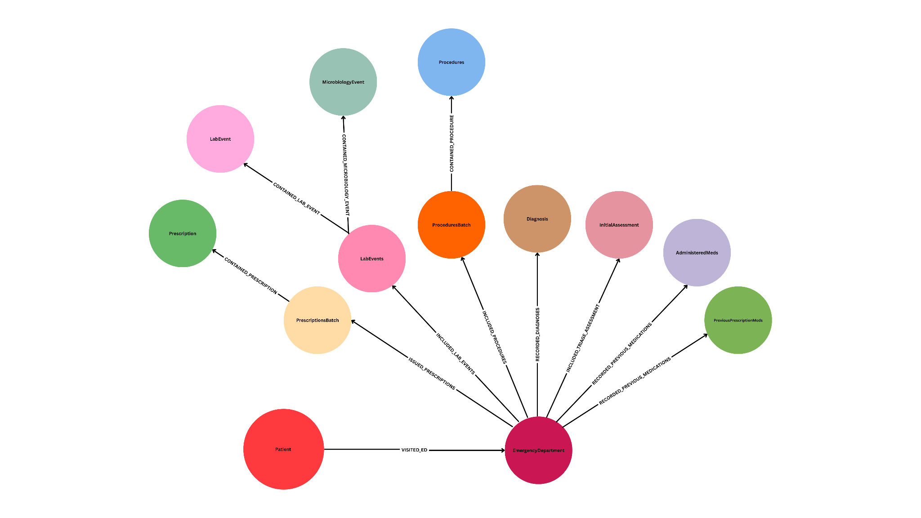
This diagram models an Emergency Department visit: a Patient visits the EmergencyDepartment, which records multiple clinical events. The ED captures InitialAssessment (triage), Diagnosis, ProceduresBatch (containing individual Procedures), LabEvents (including LabEvent and MicrobiologyEvent), and PrescriptionsBatch (containing individual Prescriptions). It also records medication history via PreviousPrescriptionMeds and AdministeredMeds, both contributing to the RECORDED_PREVIOUS_MEDICATIONS relationship. The ED serves as the central hub connecting these entities, with directed relationships (arrows) showing how patient data flows and is organized during the visit, enabling a structured representation of the clinical encounter.

Hospital Admission Relationships
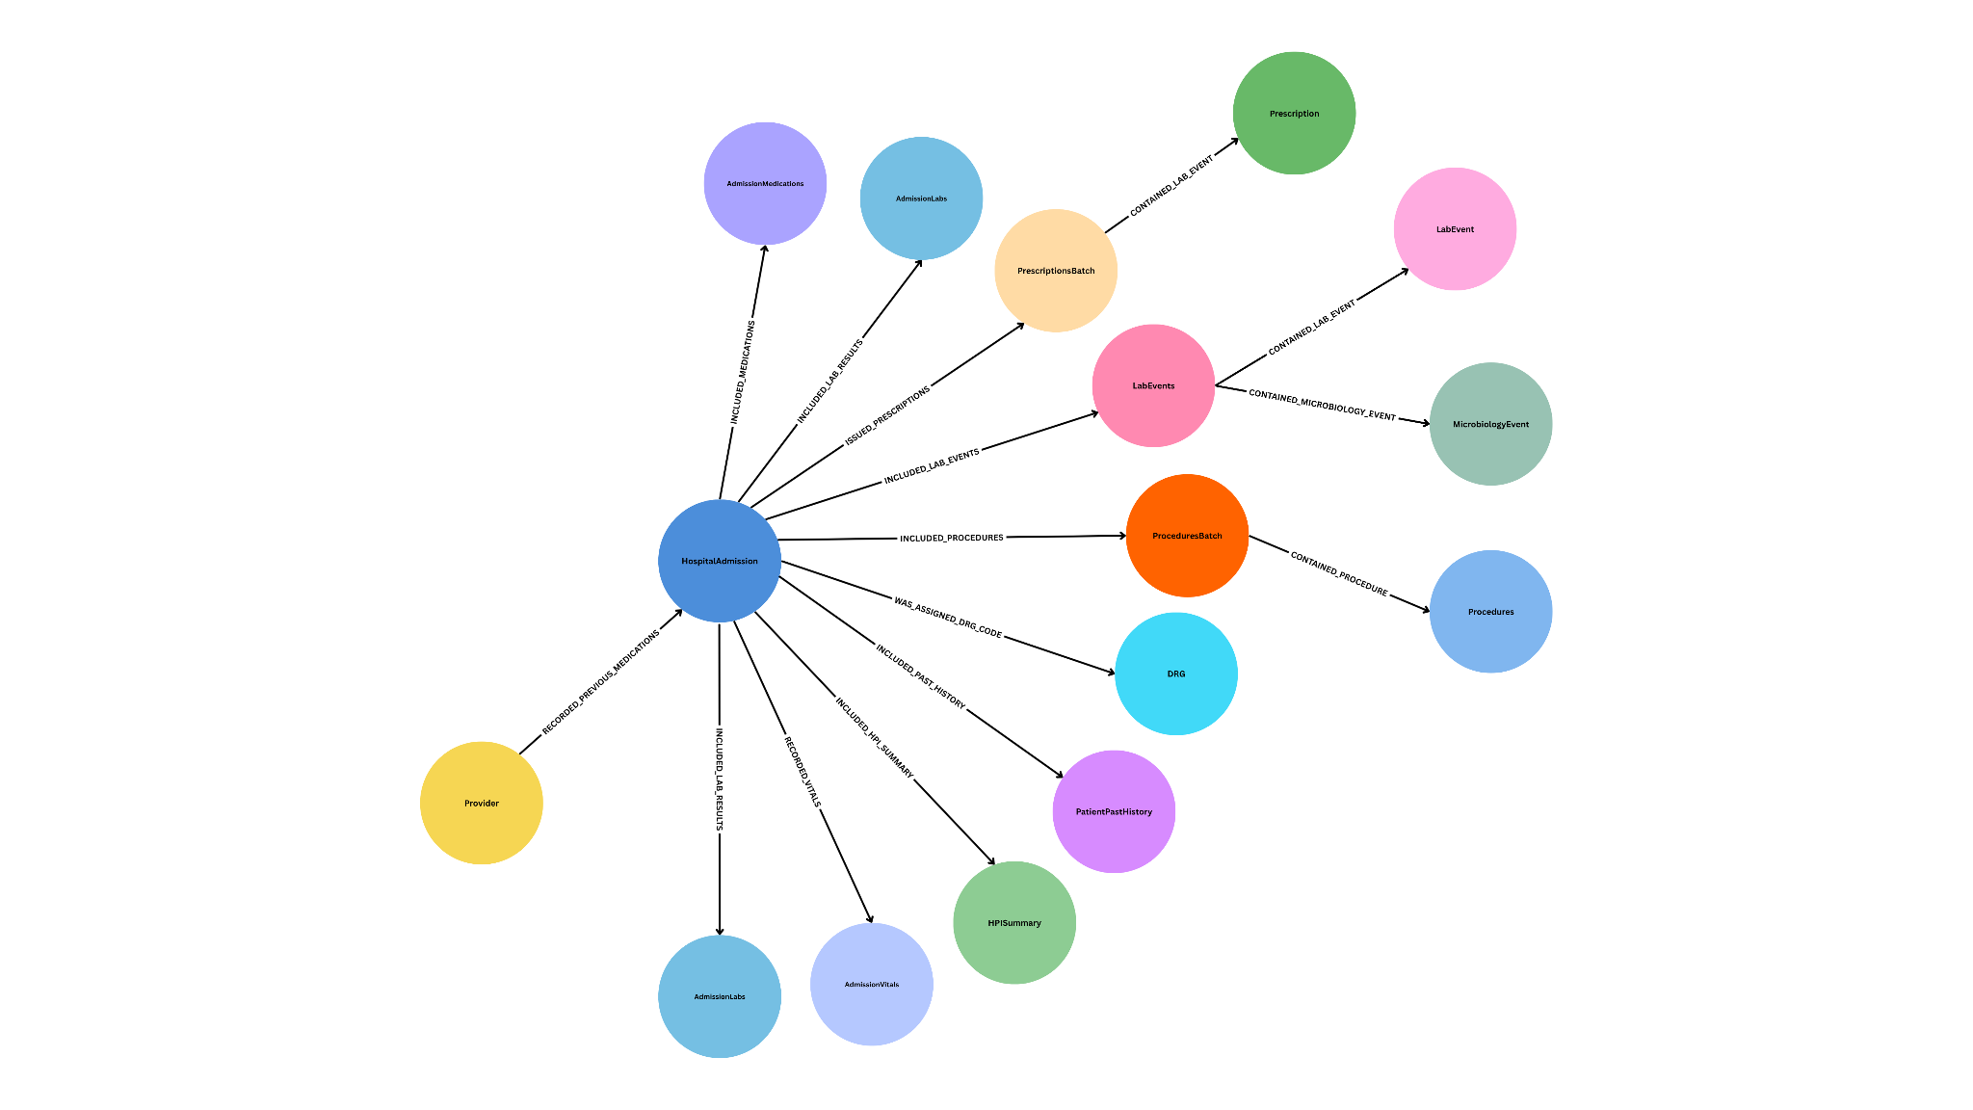
This diagram models a HospitalAdmission as the central node, linking to clinical data captured during the stay. The admission connects to AdmissionMedications, AdmissionLabs, and AdmissionVitals (captured at admission), and to PatientPastHistory and HPISummary (historical context). It also links to ongoing clinical activities: PrescriptionsBatch (containing individual Prescriptions), LabEvents (containing LabEvent and MicrobiologyEvent), and ProceduresBatch (containing individual Procedures). Additionally, the admission is assigned a DRG code for billing/classification and is managed by a Provider. The graph shows how admission data, ongoing clinical events, and administrative information are organized around the hospital admission, enabling a structured view of the patient's stay.
Unit Admission Relationships
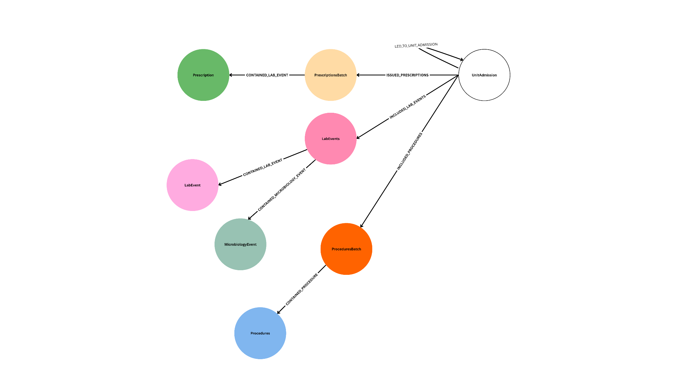
This diagram models a UnitAdmission as the central node, representing a patient's admission to a specific hospital unit. The admission is preceded by another event via LED_TO_UNIT_ADMISSION, indicating the admission flow. From the UnitAdmission, three relationships link to clinical activity batches: ISSUED_PRESCRIPTIONS connects to PrescriptionsBatch (containing individual Prescriptions), INCLUDED_LAB_EVENTS connects to LabEvents (containing LabEvent and MicrobiologyEvent), and INCLUDED_PROCEDURES connects to ProceduresBatch (containing individual Procedures). The graph shows how a unit admission aggregates prescriptions, lab events, and procedures during the stay, with batch nodes organizing individual clinical events, enabling a structured view of care delivered in that unit.
ICU Stay Relationships
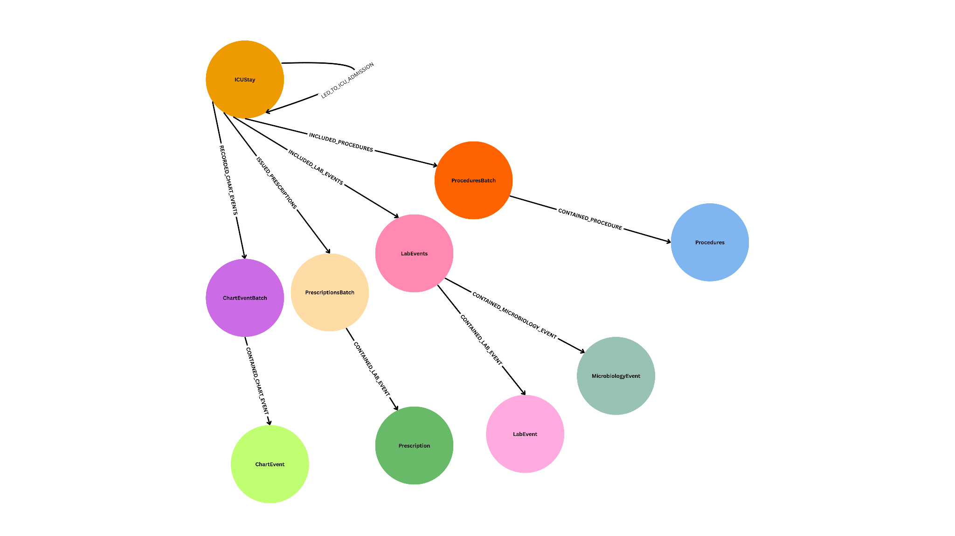
This diagram models an ICUStay as the central node, representing a patient's stay in the Intensive Care Unit. The ICUStay connects to four clinical activity batches: INCLUDED_PROCEDURES links to ProceduresBatch (containing individual Procedures), INCLUDED_LAB_EVENTS links to LabEvents (containing LabEvent and MicrobiologyEvent), ISSUED_PRESCRIPTIONS links to PrescriptionsBatch (containing individual Prescriptions), and RECORDED_CHART_EVENTS links to ChartEventBatch (containing individual ChartEvent). The graph shows how an ICU stay aggregates procedures, lab results, prescriptions, and chart events, with batch nodes organizing individual clinical events. This structure enables a structured view of the intensive care period, capturing the detailed clinical data generated during the stay.
Discharge Relationships
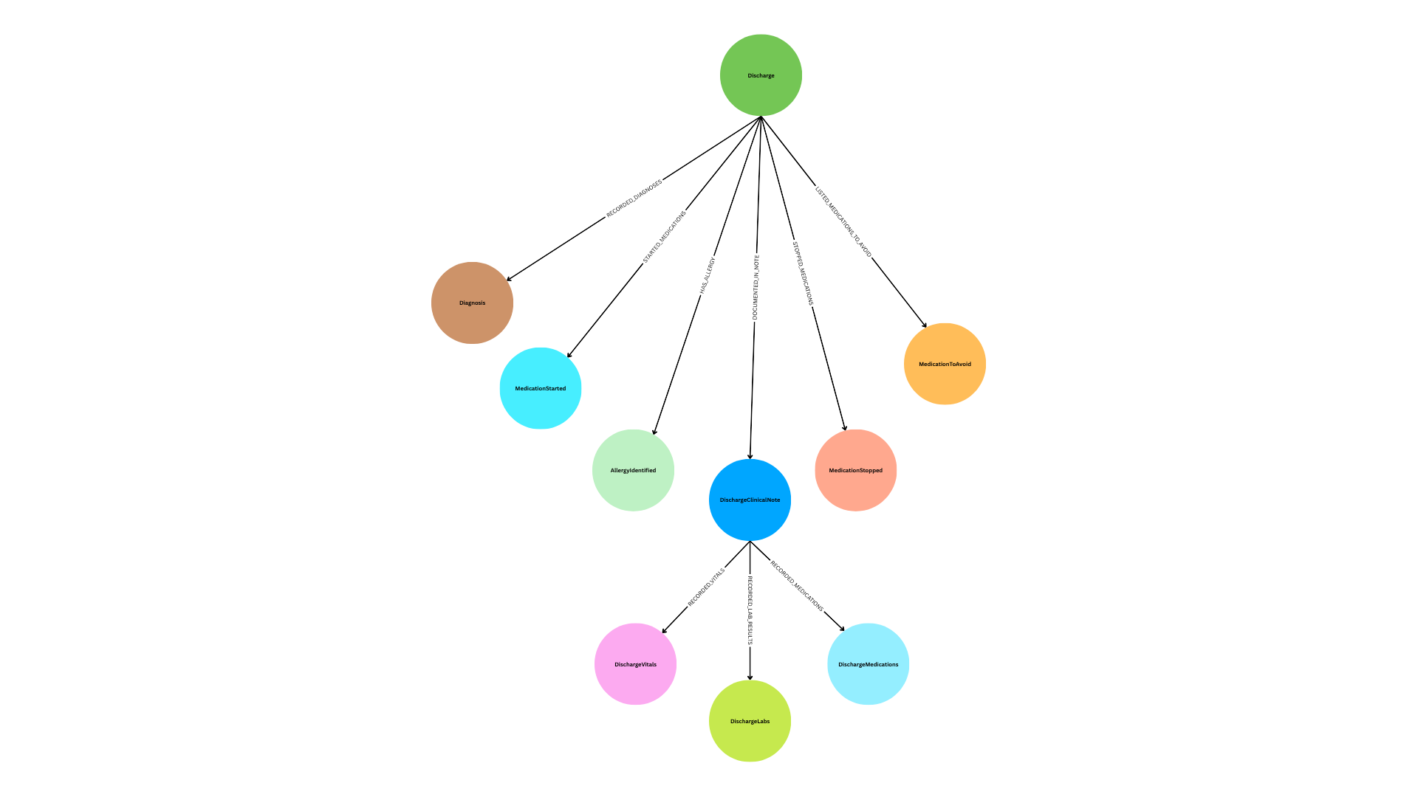
This diagram models a Discharge as the central node, representing the patient's release from care. The Discharge links directly to several clinical outcomes: RECORDED_DIAGNOSES connects to Diagnosis, STARTED_MEDICATIONS to MedicationStarted, STOPPED_MEDICATIONS to MedicationStopped, LISTED_MEDICATIONS_TO_AVOID to MedicationToAvoid, and HAS_ALLERGY to AllergyIdentified. Additionally, DOCUMENTED_IN_NOTE connects to DischargeClinicalNote, which serves as a summary document that further links to DischargeVitals (via RECORDED_VITALS), DischargeLabs (via RECORDED_LAB_RESULTS), and DischargeMedications (via RECORDED_MEDICATIONS). The graph shows how a discharge event captures diagnoses, medication changes, allergies, and a clinical note summarizing the patient's condition at discharge, providing a structured view of the care transition and final clinical state

The Patient Journey Structure
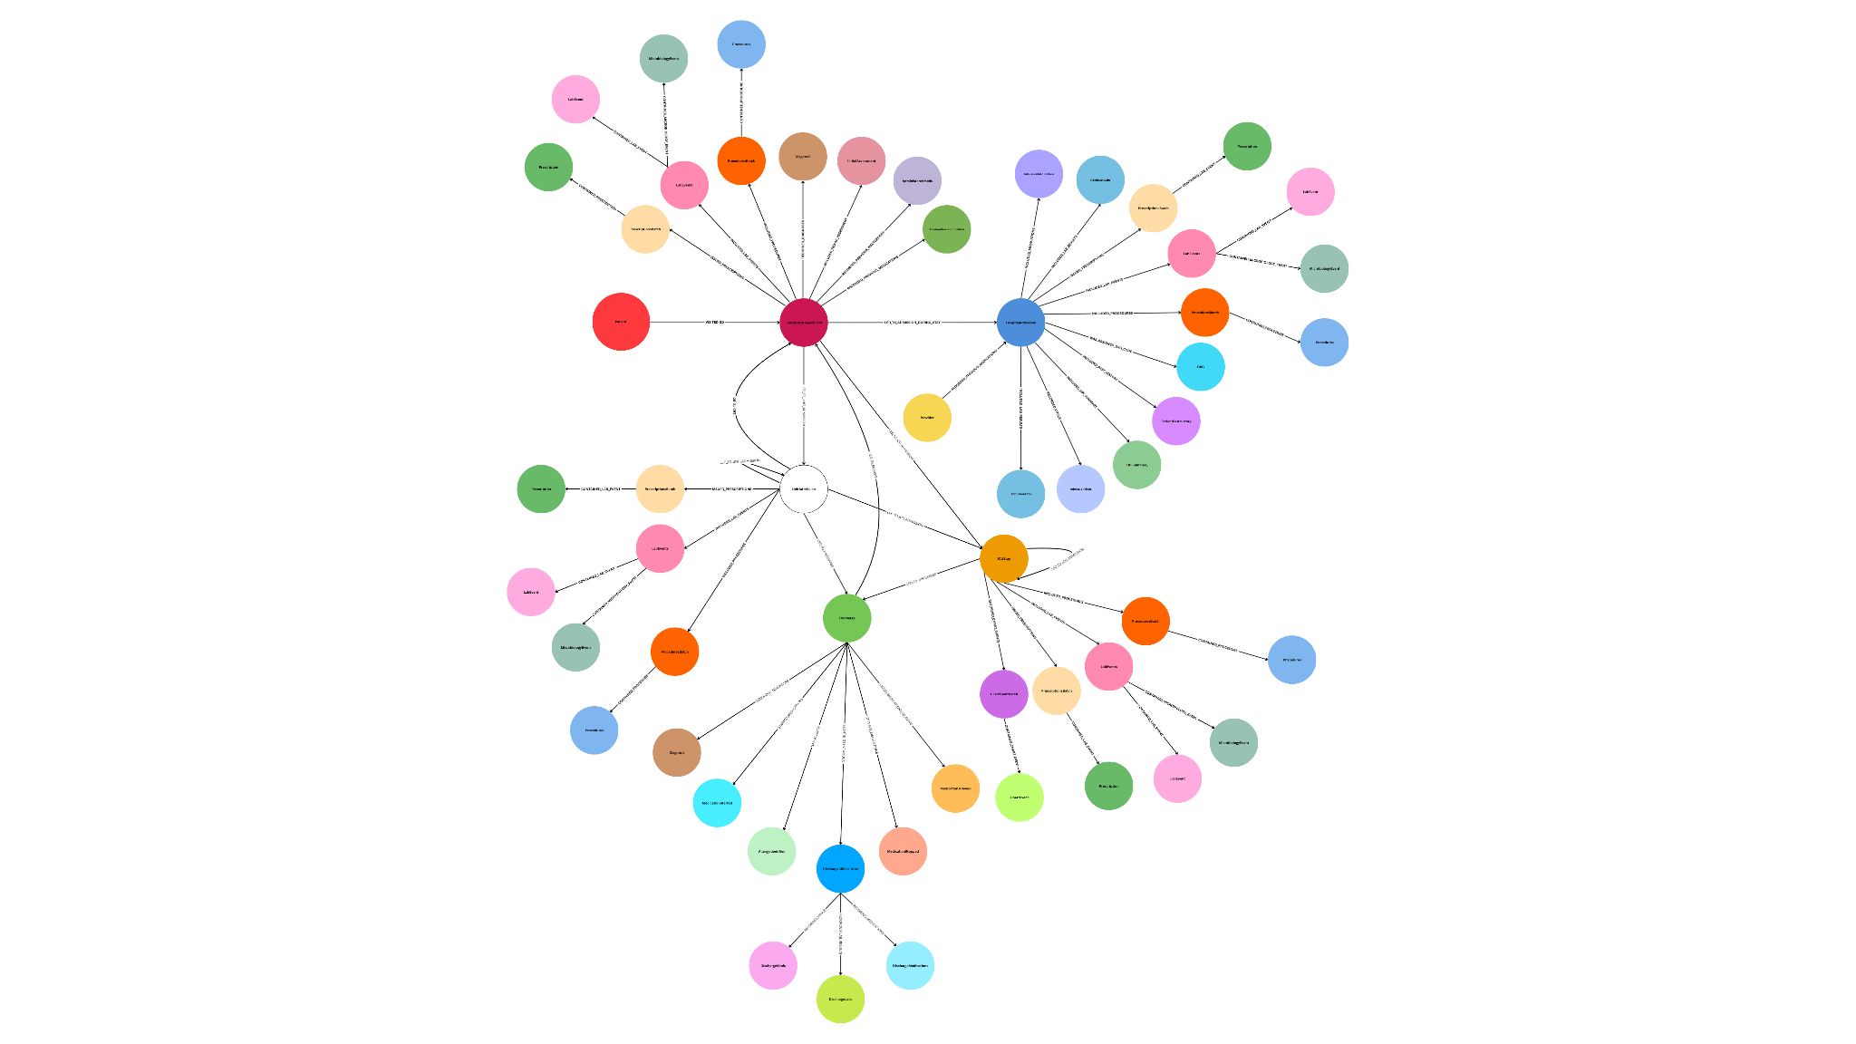
The knowledge graph models a patient's healthcare journey through five main event types:
- Emergency Department (ED) Visit : Where the patient first arrives
- Hospital Admission : When the patient is admitted to the hospital
- Unit Admission : When the patient moves to a specific hospital unit
- ICU Stay : If the patient needs intensive care
- Discharge : When the patient leaves

How Data is Organized
Each event acts as a container that links to related clinical data:
- Batch containers: ProceduresBatch, PrescriptionsBatch, LabEvents, and ChartEventBatch group similar items together
- Individual items: Each batch contains specific instances (e.g., ProceduresBatch contains individual Procedures)
- Clinical records: Diagnoses, medications, lab results, vitals, and procedures are linked to the relevant event.
Key Features
- Flow connections: Events connect chronologically (e.g., ED → Hospital Admission → Discharge)
- Patient context: Historical information (past medications, medical history) is captured at admission
- Medication tracking: Tracks medications given, started, stopped, and to avoid
- Provider linkage: Providers are linked to the admissions they manage
- Billing codes: DRG codes are assigned to hospital admissions for classification
Knowledge Graph for Single Patient ( Snapshot from Neo4j )

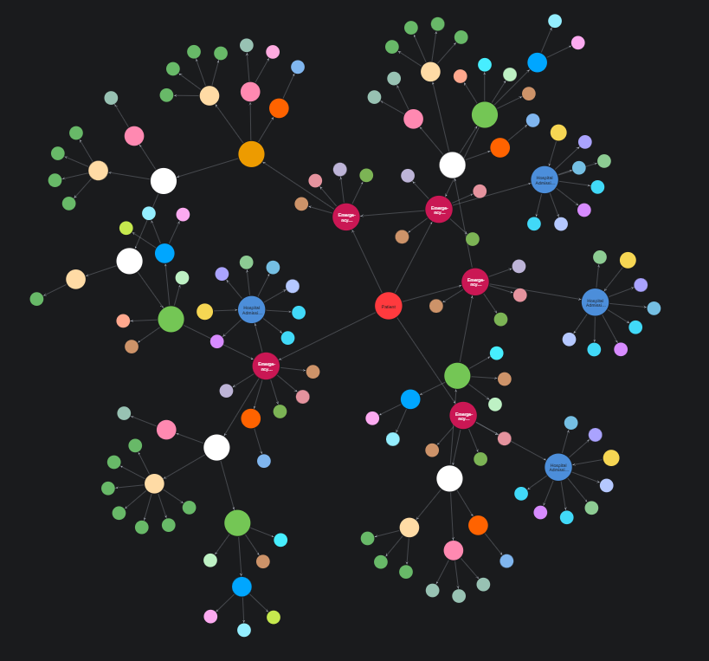

Clinical course
The patient's clinical journey reflects a rapid decline over four months due to end-stage liver disease. Her first admission in May 2180 was for ascites after self-discontinuing diuretics. She was admitted to the Transplant service, stabilized, and discharged home. She was readmitted in June with recurrent ascites, hyponatremia, and hyperkalemia, necessitating diuretic adjustment. During this stay, she underwent a diagnostic and therapeutic paracentesis. In July, she presented twice, first for post-paracentesis hypotension and then for worsening altered mental status, requiring a brief admission to the Medical Intensive Care Unit (MICU) for management of hepatic encephalopathy. She was stabilized with Lactulose and transferred back to the Transplant unit before discharge. Her final admission in August was for intractable abdominal pain from tense ascites. Given her rapid functional decline, recurrent hospitalizations, and comorbidities making her ineligible for transplant, her goals of care were shifted to comfort and palliation. A final therapeutic paracentesis was performed for symptom relief. After discussion with the patient and her family, she was discharged to hospice care

Knowledge Graph for 5 Patients ( Snapshot from Neo4j )

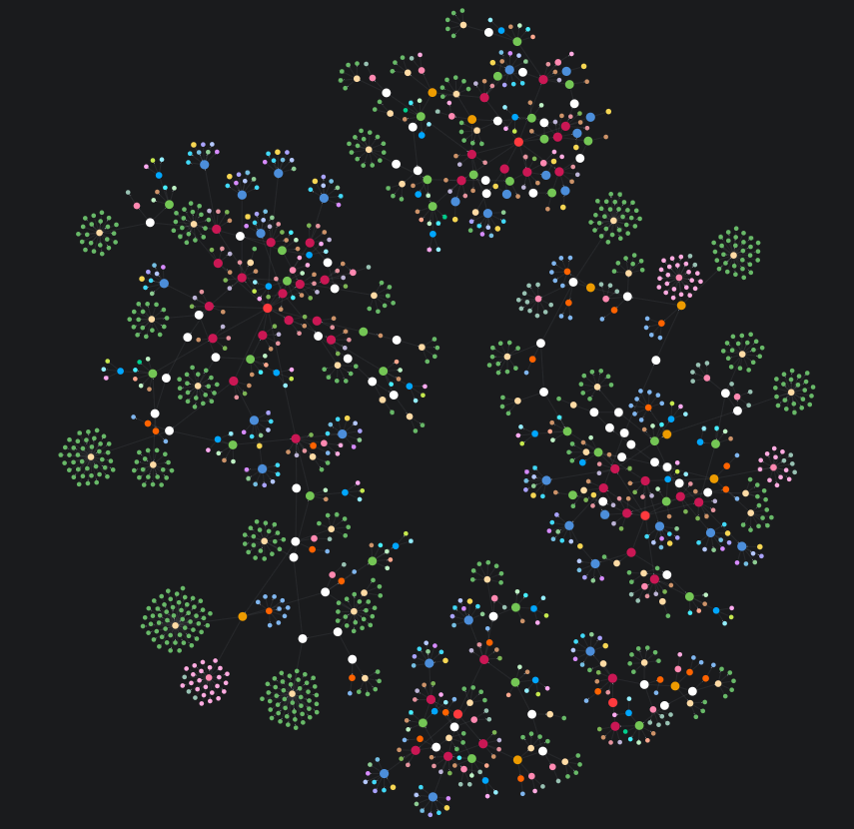

VectorDB
A Vector Database (VectorDB) is a specialized database designed to store and search vector embeddings : numerical representations of data such as text, images, or audio based on their meaning rather than exact matches. By comparing the distances between these vectors in high-dimensional space, a VectorDB can quickly find semantically similar items, enabling powerful applications like semantic search, recommendation systems, and Retrieval-Augmented Generation (RAG) for AI models.

Examples:
- FAISS (Facebook AI Similarity Search)
- Milvus
- Qdrant
- Weaviate
- Chroma
- Annoy (Approximate Nearest Neighbors Oh Yeah)
- Vespa
Embeddings
Embeddings are numerical representations of data like words, sentences, images, or
audio that captures their meaning or context in a mathematical form (usually as long lists of numbers called vectors).In simple terms, embeddings translate complex data into numbers so that machines can understand relationships like similarity or meaning.These embeddings are stored in a vector space, where similar concepts are close together.
Example
king → [0.52, 0.71, -0.33, 0.12]
queen → [0.50, 0.68, -0.30, 0.10]
apple → [-0.42, 0.10, 0.90, -0.25]

“king” and “queen” will be close together → similar meaning (both royalty)
“king” and “apple” will be far apart → different meaning (person vs. fruit)
Think of them as co-ordinates in high dimensional space where entities with similar properties are positioned together enabling mathematical similarity comparisons and semantic search.

Why are Embeddings Important in Knowledge Graph ?

Embeddings convert graph nodes and relationships into numeric vectors that capture both structure and meaning, enabling fast similarity search, semantic matching, and ML integration. They let you find similar patients even when terms differ (e.g., "heart attack" vs "myocardial infarction"), combine graph connections with text semantics, and scale to large datasets using vector indexes. This supports natural language queries, pattern discovery, and recommendations by representing complex graph data as numbers that models can process efficiently.

- Semantic Similarity Search
Embeddings let you find similar things even when the words don't match exactly. For example, you can find patients with "heart problems" even if their records say "cardiac issues" or "myocardial infarction" instead.

- Efficient Similarity Computation
Instead of slowly checking every connection in the graph, embeddings let you quickly compare patients using simple math. This means finding similar patients takes seconds instead of minutes, even with thousands of records.

- Combining Structure and Content
Embeddings can capture both the connections between nodes (like Patient → ED → Hospital) and the actual meaning of the text (like diagnosis descriptions). This gives you a complete picture that includes both how things are connected and what they mean.

- Vector Search at Scale
With vector indexes, you can search through millions of patients almost instantly to find the most similar ones. It's like having a super-fast search engine that understands meaning, not just exact matches.

- Query Flexibility
You can ask questions in plain English like "find patients with breathing problems" and the system will understand what you mean. The embeddings translate your question into a format that matches similar patients automatically.

- Machine Learning Integration
Embeddings convert complex graph data into simple numbers that machine learning models can understand and use. This lets you build prediction models, find patterns, and make recommendations based on patient data.

- Contextual Understanding
Embeddings understand that a patient's diagnosis means different things depending on their other conditions and treatments. They look at the whole patient journey, not just individual pieces of information in isolation.
Embeddings in Clinical Knowledge Graph

Embeddings convert knowledge graph nodes and relationships into dense numeric vectors, enabling semantic search, similarity matching, and machine learning. They capture both graph structure (connections and relationships) and semantic content (text meaning), allowing systems to find similar patients even when terminology differs, perform fast similarity searches at scale, combine structural and textual information, and support natural language queries. Embeddings enable applications like patient similarity analysis, semantic search over clinical data, pattern discovery, treatment recommendations, and anomaly detection, making complex clinical data accessible for analysis and decision support.
Embedding Storage Options

Neo4j Storage
Embeddings can be stored directly in Neo4j as node properties, where each embedding vector is attached to its corresponding node (e.g., Patient nodes). Neo4j supports vector indexes for fast similarity search, allowing embeddings to be queried alongside graph structure in a single database.

Pros:
- Unified data model where embeddings and graph data are co-located, enabling combined graph and vector queries
- simplified architecture with one database
- native integration with graph relationships
- transactional consistency
- vector indexes for efficient similarity search.
Cons:
- Increased memory usage as embeddings are stored with graph data
- potential performance impact on graph operations with large embedding vectors
- limited scalability for extremely large vector collections
- storage costs grow with both graph and vector data.

External Vector Database

Embeddings can be stored in specialized external vector databases (like FAISS, Pinecone, Weaviate, or Qdrant) that are optimized specifically for vector operations and similarity search. These systems maintain a separate index of embeddings and use the graph database only for storing the graph structure and relationships.

Pros:
- Optimized for vector operations with faster similarity search performance
- better scalability for large vector collections
- reduced memory footprint in the graph database
- specialized algorithms and indexing techniques for vectors
- can handle billions of vectors efficiently
- Separation of concerns allows independent scaling.

Cons:
- Requires maintaining two separate systems (graph database and vector database)
- data synchronization needed between systems
- more complex architecture with additional operational overhead
- potential consistency issues if updates aren't synchronized
- requires additional infrastructure and maintenance
- queries spanning both graphs and vectors may need multiple database calls.

Storage Recommendations

For the MIMIC-IV dataset (364,627 patients, 20M+ prescriptions, 4M microbiology events), use a hybrid approach: store node-level embeddings (Patient, HospitalAdmission, Diagnosis) in Neo4j (~1M embeddings) to enable combined graph traversal and similarity queries, and store item-level embeddings (prescriptions, microbiology events, lab results) in an external vector database (~25M+ embeddings) to handle the large volume efficiently. This balances the benefits of Neo4j’s graph-aware queries for patient-level analysis with the performance and scalability of specialized vector databases for large item collections, avoiding the memory and performance issues of storing all embeddings in Neo4j while maintaining the ability to query patient journeys with both graph structure and semantic similarity.
Structural Embeddings

Structural embeddings capture the topology and relationships of the knowledge graph by analyzing how nodes connect through edges and relationships. Generated using graph algorithms like Node2Vec or Neo4j GDS FastRP, these embeddings encode the structural context of each node by examining its position in the graph, its neighbors, and the patterns of connections within its subgraph. For example, a Patient node's structural embedding reflects its connections to EmergencyDepartment, HospitalAdmission, Diagnosis, and other related nodes, capturing the patient's journey through the healthcare system. These embeddings enable finding patients with similar care pathways even when their clinical details differ, as they focus on the structural patterns of relationships rather than the content of the nodes themselves. They are particularly useful for identifying similar patient trajectories, understanding care flow patterns, and discovering structural similarities in how patients move through different hospital units and services.

Textual Embeddings

Textual embeddings capture the semantic meaning of text content within the knowledge graph by converting clinical text data into dense numeric vectors that preserve semantic relationships. Generated using language models like SentenceTransformers, these embeddings encode the meaning of diagnoses, medications, clinical notes, and other textual information, allowing the system to understand that "myocardial infarction" and "heart attack" are semantically similar even though they use different terminology. The embeddings are created by processing all text content associated with a node such as diagnosis descriptions, medication names, clinical note summaries, and procedure descriptions and converting them into a single vector representation that captures the semantic essence of that content. This enables semantic search capabilities where queries can find similar patients based on meaning rather than exact text matches, making it possible to discover patients with similar conditions or treatments even when the documentation uses different medical terminology or coding systems.

Combined Embeddings

Combined embeddings merge structural and textual embeddings into a single unified representation that captures both the graph topology and the semantic content of nodes. This is achieved through methods like concatenation (joining the two vectors end-to-end) or weighted sum (blending them proportionally), creating a comprehensive embedding that represents both how a node is connected in the graph and what it semantically means. For instance, a Patient's combined embedding would encode both their structural journey through the hospital (ED → Admission → ICU → Discharge) and the semantic content of their clinical data (diagnoses, medications, notes), providing a complete picture that neither embedding type alone can capture. This dual representation enables more sophisticated similarity matching where patients can be found based on both similar care pathways and similar clinical conditions, making it possible to identify patients who are similar in both their structural journey through the healthcare system and their clinical presentation, which is essential for comprehensive patient similarity analysis and recommendation systems.

Important Attributes in Nodes which can help in Embeddings
1. Patient
- Gender
- anchor_age
- anchor_year_group
- dod
- total_number_of_admissions

2. EmergencyDepartment
- period
- disposition
- arrival_transport

3. UnitAdmission
- careunit
- period
- service_given

4. ICUStay
- careunit
- period
- service_given
- first_careunit
- last_careunit
- los

5. HospitalAdmission
- admission_type
- admission_location
- discharge_location
- insurance
- language
- marital_status
- race
- hospital_expire_flag
- service
- chief_complaint
- social_history
- family_history

6. Discharge
- disposition
- facility_name
- allergies
- major_procedure

7. PreviousPrescriptionMeds
- medications

8. AdministeredMeds
- medications

9. InitialAssessment
- temperature
- heartrate
- resprate
- o2sat
- sbp
- dbp
- pain
- acuity
- chiefcomplaint

10. Diagnosis
- ed_diagnosis
- complete_diagnosis
- primary_diagnoses
- Secondary_diagnoses

11. Procedures
- procedures
- source

12. Prescription
- medicines

13. LabEvent
- lab_results
- abnormal_results

14. MicrobiologyEvent
- micro_results

15. ChartEvent
- chart_measurements

16. DRG
- drg_type
- Drg_code
- description
- drg_severity
- drg_mortality

17. PatientPastHistory
- past_medical_history
- social_history
- family_history

18. HPISummary
- summary

19. AdmissionVitals
- [Dynamic Properties: Temperature, Heart_Rate, Blood_Pressure, etc.]

20. AdmissionLabs
- lab_tests

21. AdmissionMedications
- medications

22. DischargeClinicalNote
- mental_status
- level_of_consciousness
- activity_status
- discharge_instructions
- disposition
- hospital_course
- imaging_studies
- major_procedure
- microbiology_findings
- antibiotic_plan
- code_status
- facility_name
- primary_diagnoses
- secondary_diagnoses

23. DischargeVitals
- [Dynamic Properties: Temperature, Heart_Rate, Blood_Pressure, etc.]

24. DischargeLabs
- lab_tests

25. DischargeMedications
- medications

26. MedicationStarted
- medications

27. MedicationStopped
- medications

28. MedicationToAvoid
- medications

29. AllergyIdentified
- allergy_name
Hybrid Approach Flow
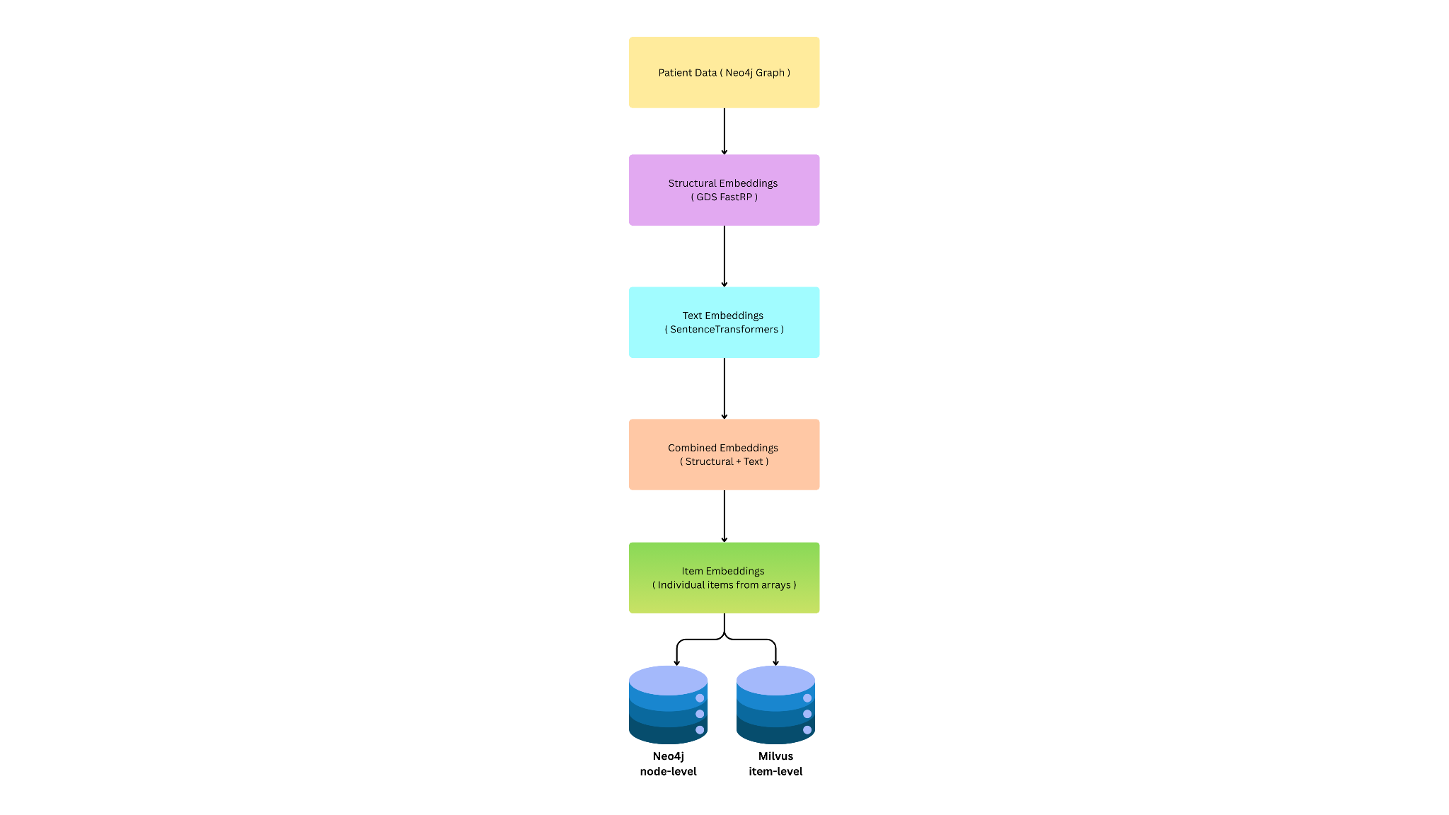

How are Embeddings created ?
The process has several steps:
- Start with Patient Data stored in Neo4j.
- Generate Structural Embeddings using Neo4j’s Graph Data Science (GDS) library these capture how nodes are connected in the graph (e.g., which patients share similar hospital visit patterns).
- Generate Text Embeddings using models like SentenceTransformers these capture the meaning of text fields (like diagnoses, notes, or medications).
- Combine the Two (structure + text) into one vector that represents both the graph relationships and text meaning.
- Store the Results
  - Neo4j keeps the node-level embeddings.
  - Milvus stores millions of smaller, item-level embeddings for fast similarity search.

Node-Level Embeddings (Neo4j)
These represent whole nodes in the graph, like Patient, Diagnosis, or Prescription.

Types:
- Structural Embeddings (128D) : show how nodes are connected in the network.
- Text Embeddings (384D) : capture meaning from text data (like “diabetes” vs “hypertension”).
- Combined Embeddings (512D) : merge both for a full picture of a patient’s profile.
For example:
- A Patient node has both text and combined embeddings.
- Other nodes (like Diagnosis or Prescription) mainly use structural embeddings.

Item-Level Embeddings (Milvus)
These are smaller, detailed vectors for individual items inside arrays.
Instead of representing an entire node, they represent each piece of data like one medication or one lab test.

Examples:
- Medication items – each drug name becomes a separate embedding.
- Lab result items – each lab test result gets its own vector.
- Microbiology results – each test or finding is embedded.
- Diagnosis items – each diagnosis code or description is embedded
These are stored in Milvus, a vector database built for similarity search, so the system can quickly answer questions like:
- “Which patients have similar medication profiles?”
- “Who had lab results like this one?”

Why Two Levels?
- Node-level embeddings give a high-level view of relationships and patient profiles.
- Item-level embeddings provide fine detail for deeper similarity searches.
Together, they let the system compare patients both broadly (entire journeys) and specifically (by individual clinical items).
Node-level embeddings (Neo4j)
All nodes included in GDS structural embeddings
These nodes are included in the GDS graph projection and receive structural embeddings (128D) via FastRP:
- Patient — also gets text (384D) and combined (512D) embeddings
- HospitalAdmission
- EmergencyDepartment
- UnitAdmission
- Discharge
- ICUStay
- Diagnosis — also used for item-level embeddings
- Prescription — also used for item-level embeddings
- PrescriptionsBatch
- PreviousPrescriptionMeds — also used for item-level embeddings
- AdministeredMeds — also used for item-level embeddings
- Procedures
- ProceduresBatch
- LabEvents
- LabEvent — also used for item-level embeddings
- MicrobiologyEvent — also used for item-level embeddings
- DischargeClinicalNote
- HPISummary
- PatientPastHistory
- InitialAssessment
- AllergyIdentified
- AdmissionMedications — also used for item-level embeddings
- DischargeMedications — also used for item-level embeddings
- MedicationStarted — also used for item-level embeddings
- MedicationStopped
- MedicationToAvoid
- AdmissionLabs
- DischargeLabs
- AdmissionVitals
- DischargeVitals
- DRG
- Provider
- ChartEventBatch
- ChartEvent
Item-level embeddings (Milvus/Neo4j)
Source nodes for item extraction
These nodes contain array fields that are split into individual items:
1. Diagnosis nodes → DiagnosisItem embeddings
- Source field: Diagnosis.primary_diagnoses[]
- Source field: Diagnosis.secondary_diagnoses[]
- Creates: DiagnosisItem nodes in Neo4j (not Milvus)
- Storage: Neo4j with vector index diagnosis_item_embedding_index
2. Medication nodes → MedicationItem embeddings
Source nodes (6 types):
- Prescription → field: medicines[]
- PreviousPrescriptionMeds → field: medications[]
- AdministeredMeds → field: medications[]
- MedicationStarted → field: medications[]
- DischargeMedications → field: medications[]
- AdmissionMedications → field: medications[]
- Creates: MedicationItem nodes in Neo4j
- Storage: Neo4j with vector index medication_item_embedding_index
3. LabEvent nodes → LabResultItem embeddings
- Source field: LabEvent.lab_results[]
- Creates: LabResultItem nodes in Neo4j
- Storage: Neo4j with vector index lab_result_item_embedding_index
4. MicrobiologyEvent nodes → MicrobiologyResultItem embeddings
- Source field: MicrobiologyEvent.micro_results[]
- Creates: MicrobiologyResultItem nodes in Neo4j
- Storage: Neo4j with vector index microbiology_result_item_embedding_index
Node-Level Embeddings are best for:
- Whole-patient similarity
- Clinical journey matching
- Semantic queries about overall conditions
- Cohort discovery
- Outcome prediction based on similar historical cases
Item-Level Embeddings are best for:
- Fine-grained medication comparison
- Specific lab value pattern matching
- Individual infection/pathogen similarity
- Drug repurposing and alternative identification
- Detailed diagnostic code matching
- Precision searches within specific data types

How Data is Linked Between Neo4j and Milvus
The system uses a reference-based link via the source_node_id field.
Neo4j Node (Prescription)
id: 12345
medicines: ["Aspirin", "Ibuprofen"]
↓
[Extract items with source_node_id]
↓
Milvus Items:
- item_id: "presc_12345_0"
- text: "Aspirin"
- source_node_id: "12345" ← Links back to Neo4j
- embedding: [0.1, 0.2, ...]

- item_id: "presc_12345_1"
- text: "Ibuprofen"
- source_node_id: "12345" ← Same source node
- embedding: [0.3, 0.4, ...]
Text extraction and embedding process
Patient data is pulled from the Neo4j graph via queries that gather attributes from related nodes (demographics, admissions, diagnoses, medications, lab results, discharge notes, etc.) and organize them into a structured dictionary. This data is formatted into a single text string, prioritized so critical information (diagnoses, allergies, medications) appears first, with categories separated by delimiters, and no truncation is applied. For embedding, the text is processed using a SentenceTransformer model: if it exceeds the model's token limit (around 512 tokens), it's split into overlapping chunks at natural boundaries, each chunk is embedded into a fixed-size vector, and the chunk embeddings are averaged to produce a single embedding vector that preserves all patient information while staying within the model's constraints.

Structural embedding generation process:
The system uses Neo4j Graph Data Science (GDS) to create structural embeddings that capture graph topology and relationships. First, it creates a graph projection from the database, selecting relevant node types (Patient, HospitalAdmission, Diagnosis, etc.) and relationship types (VISITED_ED, INCLUDED_DIAGNOSIS, etc.) to form a projected graph. The FastRP (Fast Random Projection) algorithm then processes this graph: it initializes random vectors for each node and iteratively refines them by aggregating information from neighboring nodes through message passing, with weights controlling how much each iteration contributes. The algorithm captures structural patterns, how nodes are connected, their positions in the network, and their relationship neighborhoods resulting in fixed-dimensional vectors (typically 128 dimensions) that encode graph structure. These embeddings are written back to Neo4j as properties on the nodes, allowing the system to retrieve structural embeddings for patients or other node types, which can then be combined with text embeddings to create a hybrid representation that captures both semantic meaning (from text) and structural relationships (from the graph topology).
Complete Embedding Process:
Step 1: Graph Projection Setup
Create a graph projection in Neo4j Graph Data Science (GDS) that includes relevant node types (Patient, HospitalAdmission, Diagnosis, Medication, etc.) and relationship types (VISITED_ED, INCLUDED_DIAGNOSIS, etc.) to form a projected graph for analysis.
Step 2: Structural Embedding Generation
Run the FastRP algorithm on the projected graph: initialize random vectors for each node, then iteratively refine them by aggregating information from neighboring nodes through message passing. This produces 128-dimensional vectors that encode graph structure, connection patterns, and network position. Store these temporarily as properties on all nodes in Neo4j.
Step 3: Patient Text Data Extraction
For each patient, query Neo4j to extract attributes from related nodes: demographics, admission details, diagnoses, medications, lab results, discharge notes, procedures, allergies, and other clinical information. Organize this into a structured dictionary with categorized fields.
Step 4: Text Formatting
Format the extracted data into a single text string, prioritizing critical information (diagnoses, allergies, medications) first, with categories separated by delimiters. No truncation is applied at this stage to preserve all information.

Step 5: Text Embedding Generation with Chunking
Process the formatted text using a SentenceTransformer model. If the text exceeds the model's token limit (typically 512 tokens), split it into overlapping chunks using the model's tokenizer, breaking at natural boundaries. Embed each chunk separately into 384-dimensional vectors, then average all chunk embeddings to produce a single text embedding that preserves all patient information.
Step 6: Embedding Combination
For each patient, combine the structural embedding (128 dimensions) and text embedding (384 dimensions) using concatenation (default) or weighted sum. This produces a combined embedding (512 dimensions) that captures both graph structure and semantic meaning.
Step 7: Storage in Neo4j
- Store three types of embeddings on Patient nodes: the text embedding (384 dimensions) for semantic queries, the combined embedding (512 dimensions) for patient similarity, and optionally the original combined embedding. Write these in batches for efficiency.
Step 8: Vector Index Creation
Create vector indexes in Neo4j for fast similarity search: one index on the text embedding property for semantic queries, and another on the combined embedding property for patient-to-patient similarity searches.
Step 9: Item-Level Data Extraction
Extract individual items from array fields in nodes: medications from Prescription nodes (medicines array), lab results from LabEvent nodes (lab_results array), microbiology results from MicrobiologyEvent nodes (micro_results array), and diagnoses from Diagnosis nodes (primary_diagnoses and secondary_diagnoses arrays). Each item in these arrays becomes a separate entity for embedding.
Step 10: Item Embedding Generation
Generate embeddings for each extracted item using the same SentenceTransformer model, creating 384-dimensional vectors for each medication name, lab result, microbiology result, and diagnosis code. Process items in batches for efficiency.
Step 11: Milvus Collection Setup
Create separate Milvus collections for each item type (prescription_items, lab_result_items, microbiology_items, diagnosis_items) with schemas that include fields for item ID, item type, text content, source node ID, metadata, and the embedding vector. Each collection is configured with HNSW indexing for fast approximate nearest neighbor search using cosine similarity.
Step 12: Item Storage in Milvus
Store all item embeddings in their respective Milvus collections, inserting items in batches. Each item record includes its unique identifier, the original text, the embedding vector, a reference to the source Neo4j node, and metadata about the item's position and type.
Step 13: Milvus Index Building
Build HNSW (Hierarchical Navigable Small World) indexes on the embedding fields in each Milvus collection to enable fast similarity searches across millions of items, optimized for cosine similarity queries.
Step 14: Cleanup
Remove temporary structural embedding properties from all nodes (they were only needed during generation), and drop the GDS graph projection to free up memory.
The system now has two levels of embeddings: node-level embeddings (text and combined) stored in Neo4j for patient-level similarity, and item-level embeddings stored in Milvus collections for fine-grained similarity searches on individual medications, lab results, microbiology results, and diagnoses, enabling both holistic patient matching and detailed item-level queries.
Retrieval-Augmented Generation (RAG)
RAG is an AI technique that combines the strengths of information retrieval and text generation to produce more accurate, factual, and context-aware responses. Instead of relying solely on a model’s internal knowledge, RAG first retrieves relevant documents or data from an external source such as a database, knowledge graph, or vector store based on a user’s query. The retrieved information is then fed into a language model, which uses it to generate a coherent and grounded response. This approach helps reduce hallucinations, keeps the model’s outputs up to date, and allows it to leverage large external datasets without retraining.
Graph RAG
Graph RAG (Graph-based Retrieval-Augmented Generation) is an advanced form of RAG that uses knowledge graphs instead of plain text documents for retrieval. In this approach, information is stored as interconnected entities and relationships such as patients, medications, and diagnoses in healthcare allowing the system to retrieve context-rich, structured knowledge rather than isolated text chunks. When a query is made, the model traverses the graph to find relevant nodes and relationships, then uses that retrieved subgraph to generate an informed and coherent answer. This method improves reasoning, factual accuracy, and context understanding, especially for complex, multi-hop or relational queries that traditional text-based RAG struggles with.
How Graph RAG can be used with CKG
Graph RAG lets you ask questions in plain English about your clinical data, and it answers by finding similar patients, connecting related information across the knowledge graph, and summarizing what it finds. For example, if you ask "What treatments worked best for patients like patient 12345?", it finds patients with similar conditions and journeys using embeddings (which capture meaning, so "diabetes" matches "high blood sugar"), then follows graph connections to see what medications, procedures, and outcomes those patients had, and finally generates a clear answer like "Patients similar to patient 12345 had the best results with Metformin combined with lifestyle changes, with 80% showing improved outcomes." It combines semantic search (finding similar things by meaning) with graph traversal (following relationships between patients, diagnoses, medications, and outcomes) to provide evidence-based insights that help doctors make better decisions, discover patterns, and learn from past cases without manually searching through thousands of records.

